

SOC09109 2025-6 TR2 001
Group Project
Final Delivery Report
MAP-Elites Algorithm Training

Group 277
Members:
Aswin Vazhakkoottathil Podimon (40650180)
David Weir (40654445)
Jamie Harris (40346197)
Sebastian Murray (40682339)
Robbie Black (40582304)
Kipras Tomkevicius (40681851)

Client: Simon Smith
Sponsor: Leni Le Goff

Table of Contents
1. EXECUTIVE SUMMARY 2
2. Project Management & Team Organisation 3
2.1 Team Structure and Workflow 4
2.2 Team Members and roles 4
2.3 Timeline and tasks 4
2.4 Risk Management 4
Hardware limitations 5
HPC Access 5
3. MoSCoW validation and Status 5
3.1 Must Haves 6
a. MAP-Elites Algorithm 6
b. Isaac sim integration 6
c. Parallel Computing 6
3.2 Should Have 6
3.3 Could have 7
3.4 Won’t have 7
4. Technical Implementation 7
4.1 System Architecture 7
4.2 The MAP-Elites Algorithm 7
4.3 Experimental Results 8
4.4 Fitness Function 8
Appendices 8
Appendix A: Client Approval 9
Appendix B: Stakeholder Satisfaction Report 9
Appendix C: Lessons Learned 9
Appendix D: Peer Review 11
Appendix E: Gantt chart 11
Appendix F: GitHub Kanban Board 11
Appendix G: Isaac Sim Screenshots 12
Appendix H: Results 12
Appendix I: Heatmap 13
Appendix J: Pseudocode 14
Appendix K: Calendar 15

EXECUTIVE SUMMARY

This document serves as the formal proof of project completion for Group 277. The project delivers an implementation of the MAP-Elites algorithm in NVIDIA Isaac Sim for parallel quadruped robot controller optimisation. The project is a deliverable for SOC09109 module for client Simon Smith.

The team built five python files to share different components of the system. A neural network controller (controller.py), a behavioural archive (archive.py), an Isaac sim interface (simulation.py) and file to visualise the results(visualise.py). The algorithm evolves 160-weight neural network controller for the ant robot by running parallel episodes in Isaac sim, recording where each ant lands and how much energy it uses. It then maintains a grid of the best controller found for each region of space.

With the corrected code submitted here, we achieved these results with parallel computing:

Metric | Result
Archive coverage | 100%
Best Fitness | 100 (distance-weighted score)
Fitness improvement across run | Consistent increase generation 1 to 100

2. Project Management & Team Organisation

2.1 Team Structure and Workflow
The project was executed by a six-person team. Each member of the team was assigned specific technical roles with respect to their hardware access and knowledge. Work was coordinated via GitHub and Discord

2.2 Team Members and roles

2.3 Timeline and tasks
An iterative process was followed throughout the project. Tasks were broken into separate files and action. It was tracked using a Kanban board. A Gantt chart was created based on feedback from the PIR.

- Revised Gantt Chart
[Appendix E]

- Kanban board
[Appendix F]

2.4 Risk Management

Hardware limitations
During the project, hardware limitations were found. Only certain machines with specific hardware were able to run Isaac sim. One of the members of the simulation team could not physically see the robots simulated, hence after long runs of simulation the json file with genome data would be sent across teammates to verify and test again.

The mitigation strategy was an asynchronous development process. Developers would write code locally and push it to the repository’s develop branch. Then the simulation team will pull and test the code and distribute the error logs to developers. Some local changes also had to be made in certain scenarios to fit the machine. (Appendix I)

HPC Access
University High Performance Computer was initially planned for large scale training. Due to time constraints and complexity of the project, it was not achieved. The project rescoped local GPU hardware. The max generations were capped to 100. This decision is documented in main.py.
Role | Members | Responsibility
Project Manager | Aswin, Jamie | Task allocation, client and sponsor communication, documentation
Lead Developer | Robbie | main.py and archive.py
Simulation and Testing | Kipras, David | Isaac sim setup and real testing
Visualisation, Documentation | Seb | Visualisation.py, Report

3. MoSCoW validation and Status

3.1 Must Haves
Requirement | Status | Evidence
MAP-Elites algorithm in Python | Delivered | archive.py
Algorithm integrated with Isaac Sim | Delivered | simulation.py
Parallel evaluation of controllers | Delivered | controller.py
Full understanding of Isaac sim based on the Scope of the Project | Delivered | Succefully created and implemented a MAP-Elites algorithm within Isaac Sim and debugged errors.

MAP-Elites Algorithm
MAP-Elites is implemented across controller.py, archive.py and main.py. The Archive class sustains a 10x10 grid where each cell stores the highest fitness controller for that region in an (x,y) space. Controllers are replaced only if they improve than the existing cell occupant. The Controller class implements an 8-input, 10-hidden, 8-output MLP with 160 trainable weights.

Isaac sim integration
The simulation class provides an interface to Isaac Sim. It loads the simulator with new values and reads back world frame position and joint velocities after the episode.

Parallel Computing
Parallel evaluation is achieved through Isaac Sim's vectorised environment API. Each call to sim.evaluate() runs all the controls simultaneously. During testing, 40 to 500 parallel environments were confirmed running on an NVIDIA RTX 3050 Ti. See Appendix F for screenshots.

3.2 Should Have
Requirement | Status | Evidence
Algorithm Documentation | Delivered | README.md and inline comments
Psuedocode | Delivered | Appendix I
Code comments | Delivered | All five files contain docstrings
Research Notes | Delivered | Notes folder in the Repository

3.3 Could have
Requirement | Status | Reason
Physical robot implementation | Not delivered | Time constraints
Algorithm for different test conditions | Not delivered | Time constraints

3.4 Won’t have
Requirement | Status | Reason
Running physical quadruped robot | Not delivered | Out of scope per PIR
Jumping quadruped robot | Not delivered | Out of scope per PIR

4. Technical Implementation

4.1 System Architecture
The project is structured to have five python files.
File | Purpose | Owner
controller.py | Neural network brain, 160 weights, mutation, crossover | Jamie
archive.py | MAP-Elites grid, insert/sample logic, save/load | Robbie
simulation.py | Isaac Sim interface mock and real modes, parallel evaluation | David, Kipras
main.py | Evolutionary loop, ties all modules together | Robbie
visualisation.py | archive heatmap and metrics graphs from CSV | Sebastian

4.2 The MAP-Elites Algorithm
The MAP-Elites is quality-diversity algorithm that maintains a collection of high-performing solutions across a space of behaviours. MAP-Elites seeks to fill a behavioural map with the best solution found for each behavioural niche.
The algorithm as implemented:
- Initialisation: generate POPULATION_SIZE random controller genomes
- Evaluation: run each controller in Isaac Sim for one episode (200 timesteps)
- Description: extract final (x,y) position as the behaviour descriptor
- Score: compute fitness as a distance weighted energy score
- Archive: insert into 10x10 grid. Replace only if there is an improvement
- Selection: sample controllers from the archive for the next generation
- Variation: apply gaussian mutation (strength 0.25) and blend crossover
- Repeat for MAX_GENERATIONS iterations

4.3 Experimental Results
Three experimental configurations were run. The key results are summarised below:
Running 100 environments running the sim for over 100 generations would sometimes cause to the sim hanging, leading to a crash. We then limited our generations to 100 and environment number to 50 –100. (Figure G1)
Initially the calculation for fitness was based on energy, however this led to the robots prioritizing energy too much causing them to simply stand still and use the least energy possible (Appendix G). This led to positions being very close to (0,0) (Figure G2) as seen in the screenshot. The fitness formula was revised to weigh distance more heavily. (Figure G3)

4.4 Fitness Function
The fitness function was developed iteratively during testing. The team made changes to the prioritisation of the distance parameter through iterations.
The final real-sim fitness formula rewards distance travelled while penalising energy expenditure:
fitness = 10 * distance – 0.1 * avg_energy
Figure G3 shows an earlier iteration of the formula for context

Appendices

Appendix A: Client Approval

[screenshot of final email from simon]

Appendix B: Stakeholder Satisfaction Report
2-3 sentence objective summary of the feedback received from Simon during the project or at the final handover.

Appendix C: Lessons Learned

- Unforeseen absences and late admission

Problem: The project faced early disruption when the original project manager required authorised absence during the initiation phase. Separately, a sixth team member (Robbie) joined in week 5 of the project.
Improvement Implemented: A team member stepped up as interim PM (Jamie), taking ownership of the PIR and client meetings. Robbie was introduced to the system and assignments were redistributed accordingly and communicated via Discord.
Reflection: In future projects, a documented role succession plan should be established at the outset so that any absence does not disrupt the workflow. Keeping a document underlining the project structure and details could be useful if addition of members is needed in the team. The team adapted well under the circumstances.

- Hardware constraints and asynchronous development
Problem: The team lacked consistent access to machines with the required GPU specifications to run Isaac Sim natively. Developers had to write code without having access to a simulator to test their code.
Improvement Implemented: A USE_MOCK = True toggle and _run_mock() function was introduced in simulation.py and main.py, allowing developers without Isaac Sim access to run their code and look for errors without using the simulator. Code was developed locally and pushed to github. The simulation team would test the code and give feedback to the developers.
Reflection: The mock system proved to be a quick fix that enabled faster coding. However, there were a lot of bugs as it was not written for the simulator. In future, establishing a shared testing environment (such as a remote development server or cloud GPU instance) earlier in the project would close this gap.
- Inability to Access High-Performance Computing (HPC)
Problem: The team initially planned to use the university’s HPC cluster to run large-scale training. This proved unachievable due to a combination of time constraints and insufficient familiarity with Slurm job scheduling and Apptainer containerisation at the project’s outset.
Improvement Implemented: The project was rescoped to run entirely on local GPU hardware. Parameters were adjusted to fit available resources: MAX_GENERATIONS = 100 , POPULATION_SIZE = 5 , and device = torch.device(“cpu”) in main.py.
Reflection:The team underestimated the initial setup overhead involved. In a future project with similar requirements, we would allocate a dedicated sprint early on to environment setup and access verification, independent of algorithm development. It would have been preferable to make this decision earlier rather than under time pressure.

- Conflicting Module Deadlines and Time Constraints
Problem: Concurrent coursework deadlines from other modules significantly reduced available working hours across the team. This caused initial task estimates on the Gantt chart to slip and created periods where progress stalled.
Improvement Implemented: The team decided to solely focus on delivering Must-have requirements first. The team also created a calendar in week 4 to figure out which days we could work together. [Appendix K]
Reflection: The initial Gantt chart was built on optimistic availability estimates that did not account for other module deadlines. The change to a tighter agile cycle was effective once made but applying it from the very beginning rather than a reactive measure would have prevented the initial pressure which involved meetings with a lot of the members missing due to conflicts.

Appendix D: Peer Review


Appendix E: Gantt chart

Appendix F: GitHub Kanban Board
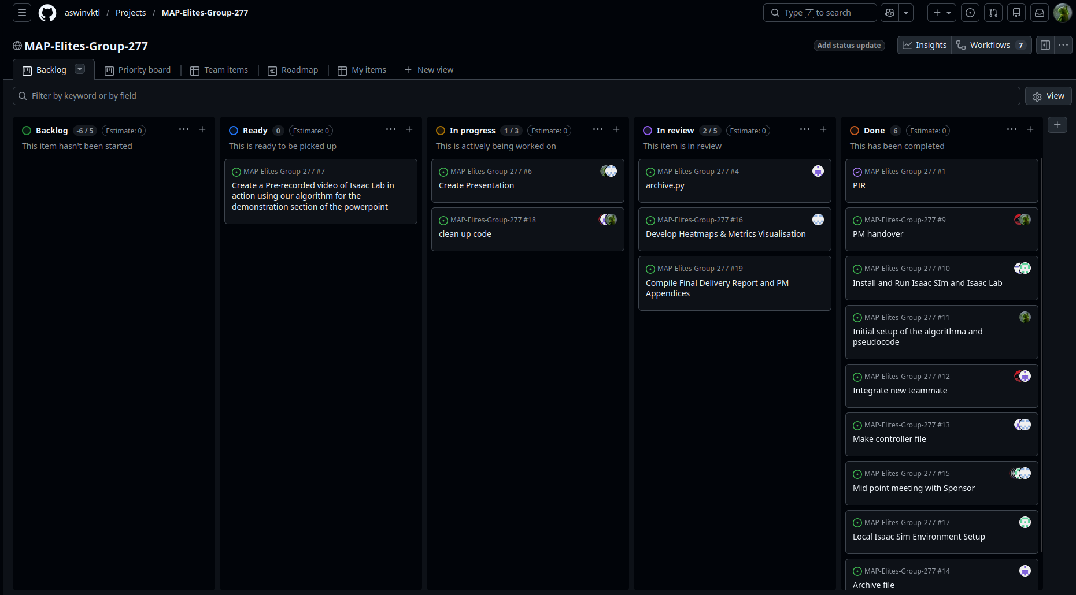

Appendix G: Isaac Sim Screenshots
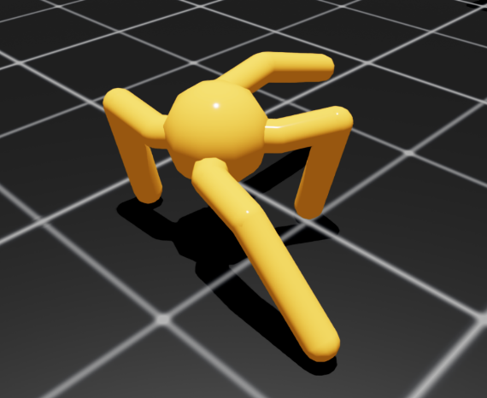
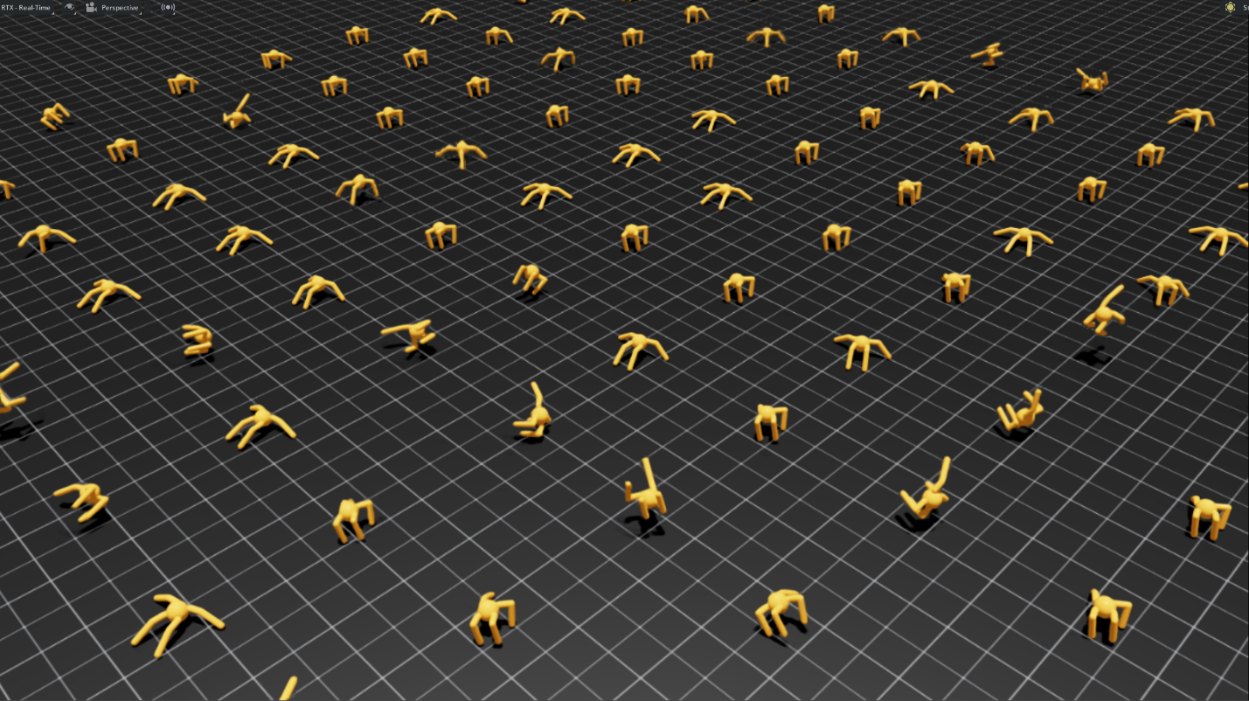

Appendix H: Results

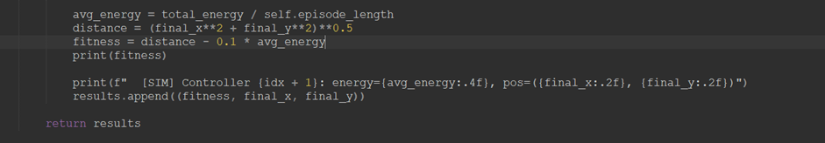
Figure G1: Isaac Sim crash dialog encountered during 100-environment runs

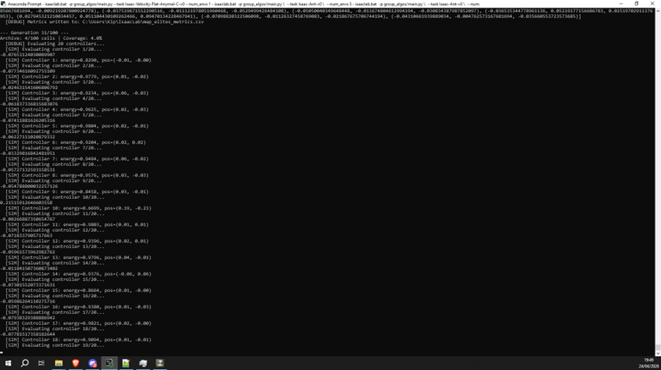Figure G2: The output from initial configuration

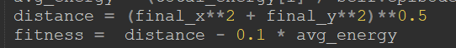
Figure G3: fitness formula prioritizing distance travelled more over average energy expenditure (Old iteration)
(need 100% csv and screenshot of sim having 100% coverage here)

Appendix I: Heatmap
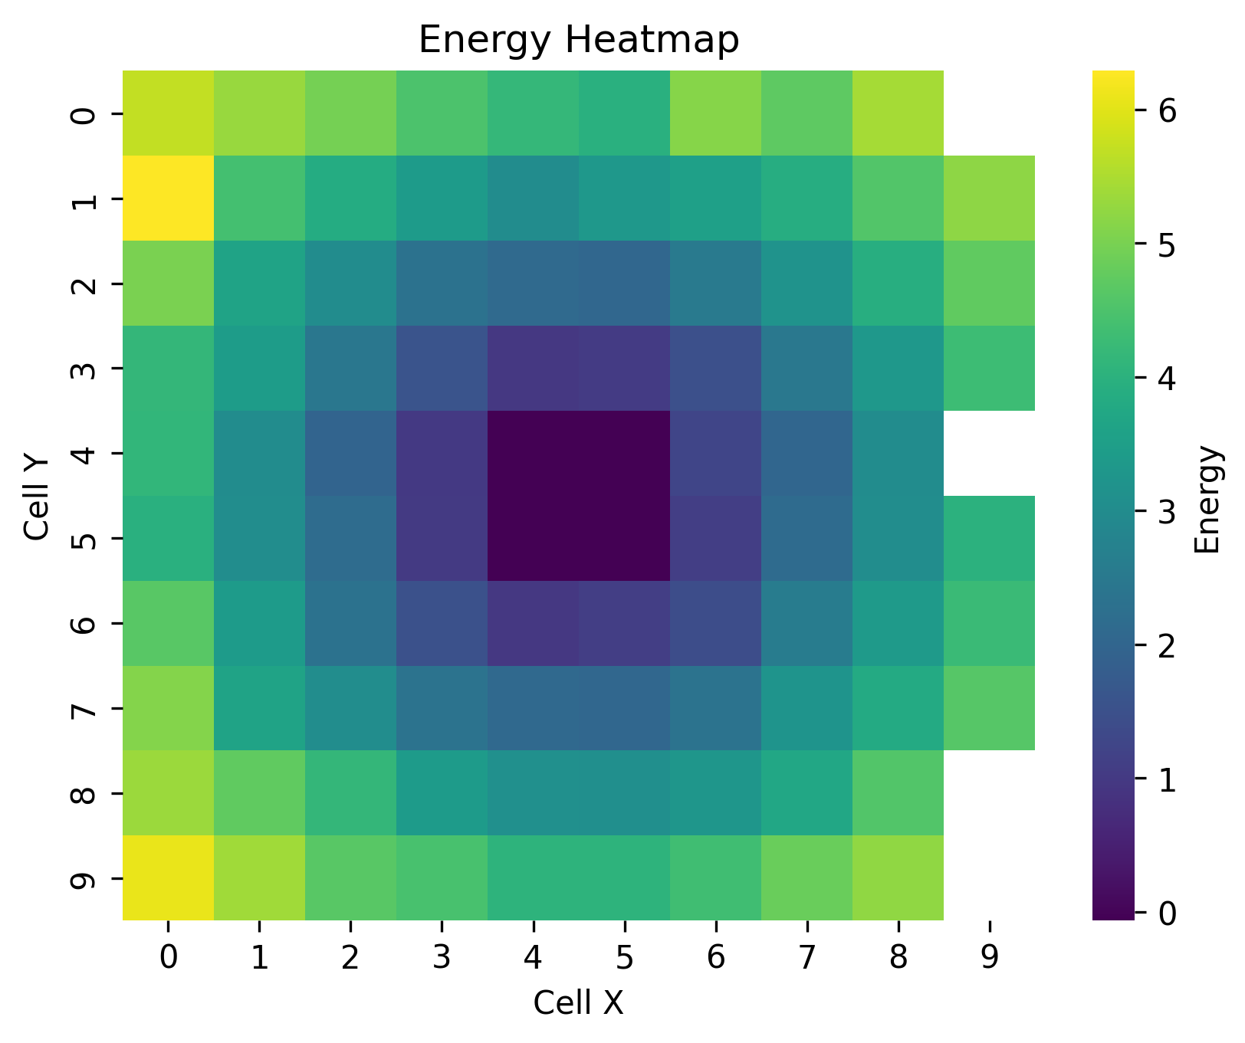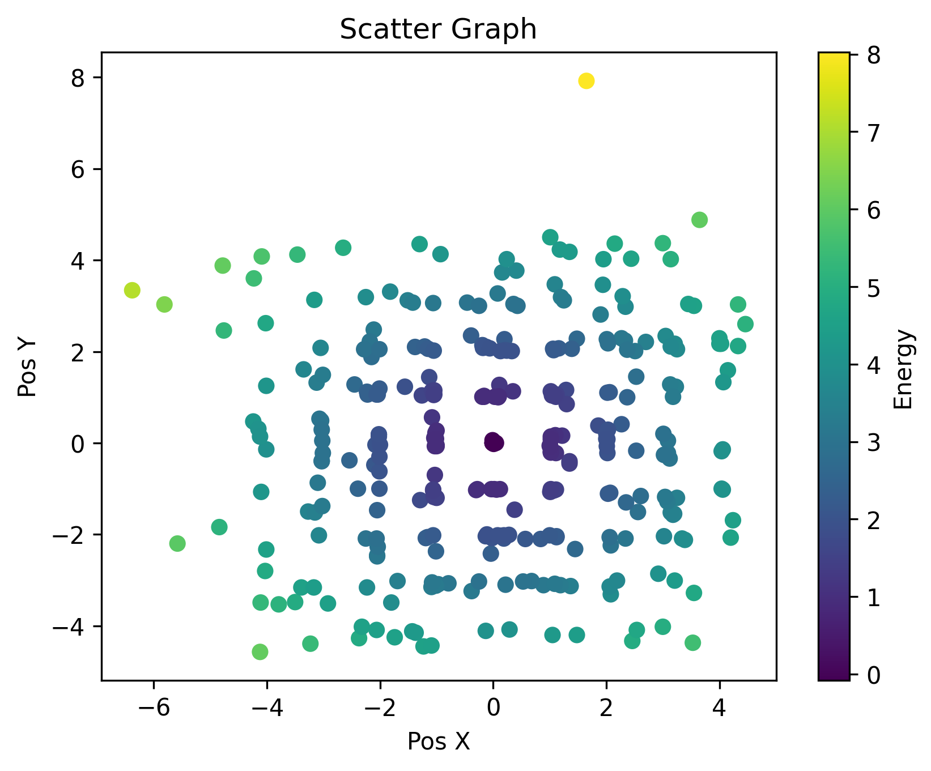

Appendix J: Pseudocode
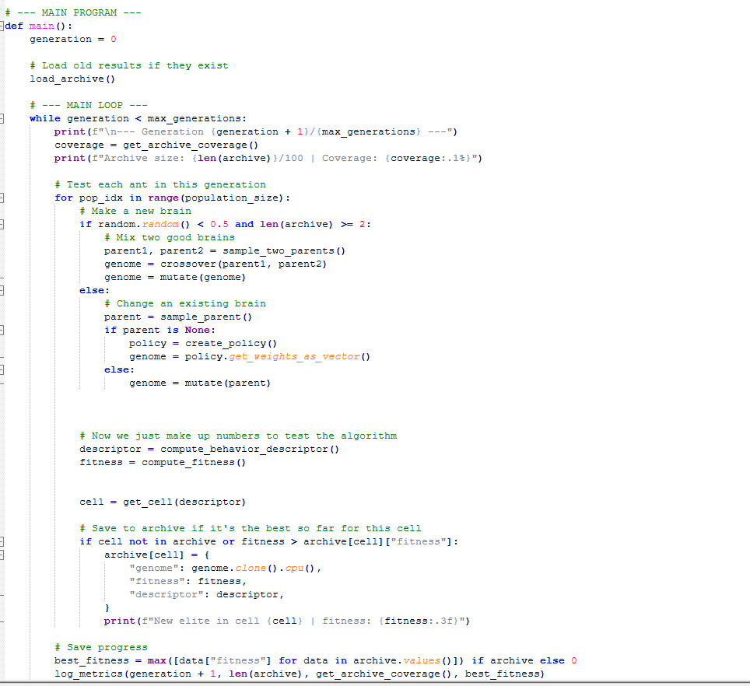

Appendix K: Calendar

